St Gregory’s Catholic Primary School
Newsletter 26/5/23
Parent meetings
Thank you so much to all the parents and carers who attended the two meetings yesterday evening. It was a wonderful opportunity for me to introduce myself, talk about my plans for the school and to answer your questions and hear your concerns.
The following issues were discussed:
- Schemes of work for RE and PHSE being available to parents.
- A list of books studied in each class on the website.
- Parents’ consultation evenings, the need to have longer appointments and how to cater for parents/carers who cannot make evening meetings.
- The need for more events in school and to invite parents/carers to them.
- Communication, why it must improve and using fewer methods of communication as it can be confusing; it was suggested that the school should use noticeboards on each playground to display news.
- Books for Nursery children to read at home.
- How support staff are deployed in school and why this is changing.
- Reviews and target-setting for pupils with SEND – involving pupils and parents/carers; holding meetings at different times to allow parents/carers to attend.
- Staffing – the school has experienced significant staffing instability, but this will no longer be the case as we are appointing permanent staff, including two this week; inform parents/carers if there are any changes.
- Sacramental celebrations – many parents/carers said that Confirmation this year had been rushed and lacklustre and they were concerned that First Holy Communion on June 11th would be the same. Issues with our parish priest being ill have caused some difficulties with arrangements but every effort will be made to ensure that it is a joyful and memorable celebration for everyone.
- Residential – several parents/carers said that the Frank Chapman residential trip was too expensive and that the school should look at an alternative.
- Lack of a Year 6 trip – a trip has now been organised and further details will be sent out soon.
- Year 6 Leavers’ Party – many parents/carers expressed their anger and considerable frustration at what they said was a lack of communication and confusing mixed-messages around the Leavers’ Party. It was explained that this was due to MAC-wide policies over which the school has no control. An event outside of school has now been organised. Parents/carers would like more information about the MAC, its structure and what it does.
- Restoring the links between the school and the parish – initial contact has been made with the parish and the Principal will attend Mass at St Gregory’s as often as his own parish duties permit, starting this Sunday. Going forward, school Masses will be celebrated in church and children will read at weekend Masses; joint events such as processions will follow in due course. The Principal will recruit and train new altar servers.
All the above have been passed on to staff for action. For those parents/carers who approached me with individual questions and concerns, the relevant staff have been informed.
Another open forum meeting will be arranged early in the next academic year. If you cannot attend, I am more than happy to meet with you at a mutually convenient time.
Staff News
Today, we say goodbye to Mrs Bonner-Hollinghead and Miss Squire. Mrs Bonner-Hollinghead has been working as one of our learning support assistants and Miss Squire has been teaching 5S. On behalf of all the staff, I would like to thank both for their hard work and commitment during their time with us at St Gregory’s.
After half-term, 5S will be taught by Ms Brown who is a highly experienced teacher who comes to us highly recommended. I am happy to say that we will have two new learning support assistants joining us, Miss Heathcock and Miss Loftus.
Uniform
The children look so smart in their uniforms – thank you. We are incredibly proud of our school and one of the ways we show that is through wearing our uniform. Please can you ensure that you child is wearing shoes, not trainers, on days that they are not doing PE.
Statue of St Gregory
Following an appeal I made to fellow clerics in the Archdiocese, we now have a rather magnificent carved wooden statue of St Gregory the Great, our patron saint, in our reception area. We are going to design a suitable display with the children to provide St Gregory wiith a fitting backdrop.
Mass at Our Lady of Good Counsel and St Gregory the Great Church
It would be wonderful to see as many of our families as possible at Mass. Our school would not be here without the church, Catholicity is central to who we are as a school community and Roman Catholics are obligated to attend Sunday Mass as part of their commitment to their faith.
The Mass times are Saturdays at 5pm and Sundays at 9 am and 11 am.

Thank you for making me feel so welcome during my first half-term (hopefully of many) as Principal of St Gregory’s. I feel immensely privileged to have been given the responsibility of leading the school community. Our pupils are amazing and, as I tell them, we are the best school in the Black Country!
On behalf of all the staff, I wish you a happy and relaxing half-term break. God bless you and see you again on Monday 5th June.
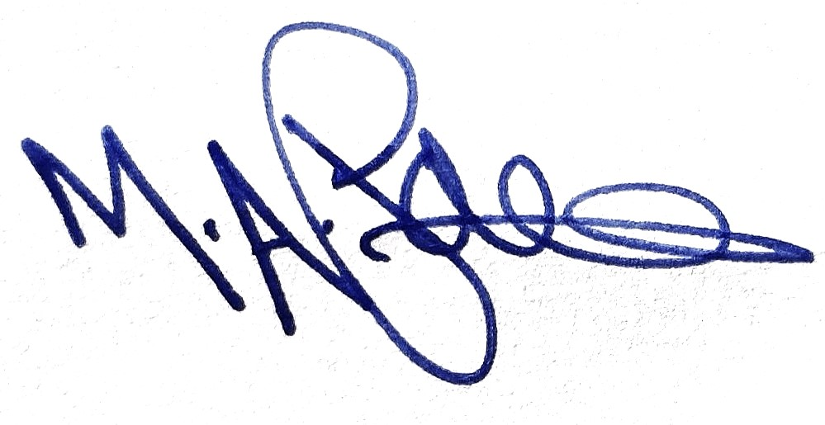
Reverend Mark Paine
Principal

Dates for your diary
Week beginning 5th June:
Monday 5th: School opens to staff and children
Wednesday 7th: Class 6 swimming
Friday 9^{th:} Irish dancing
Sunday 11th June: Class 3 First Holy Communion Mass at 11a.m. at St Gregory’s Church
Week beginning 12th June:
Monday 12^{th:} Trip for Class 2 to Cadbury World.
Wednesday 14th: Class 6 swimming
Friday 16th: Irish dancing
Week beginning 19th June:
Tuesday 20th: Frank Chapman residential information meeting at 5pm, for current Year 5 families
Wednesday 21st: Class 6 swimming
Friday 23rd June: INSET day- school closed to all children
Week beginning 26th June:
Wednesday 28th: Class 6 swimming
Wednesday 28th June: theatre trip for Classes 3,4 and 5. Details to follow shortly.
Thursday 29th: Years 4-6 Sports morning at Our Lady of Fatima School. Details to follow shortly.
Friday 30th: Irish dancing
Week beginning 3rd July:
Wednesday 5th: Class 6 swimming
Friday 7th: Final Irish dancing session
Week beginning 10th July:
Wednesday 12th: Class 6 swimming
Friday 14th: PTA summer fair. 3:30pm.
Week beginning: 17th July
Wednesday 19th: Class 6 final swimming lesson
Week beginning 24th July:
School closes for the summer break at 3.25pm on Tuesday 25th July 2023

